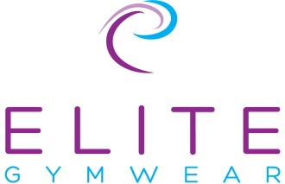
Elite International Returns/Exchange Form

Thank you for ordering from Elite International. We hope you like the goods you have ordered.
If you have any queries about your order please call us on 01827 717703.

How to return your goods
Please complete the form below completing ALL possible details.
You are responsible for the cost of returning the items, and are responsible for any returned goods until they reach our warehouse; we recommend that you obtain proof of posting.
Please enclose any payment for exchange goods that cost more than those you are returning.

Guarantee
If you are not satisfied with any of the goods enclosed please return them to us using this sheet & we will process them as soon as possible.

Important information
All items MUST be returned within 21 days of receipt of garment – any returns received after this time will be at Elite International’s discretion & we will offer customers a credit note to the full value, refunds will NOT be issued. This does not affect a customer’s statutory rights or the right to return faulty goods.
We cannot accept worn or washed or untagged items unless faulty. Items will be returned
Items which have been personalised are non-returnable.

NAME: ………………………………………………………………………………………………………………
ADDRESS: ……………………………………………………………………………………………………………………………………………………………
……………………………………………………………………………………………………………………………………………………………
POSTCODE: …………………………………………
TELEPHONE NUMBER: …………………………………………………………………
EMAIL ADDRESS: …………………………………………………………………………..
DATE OF ORDER: ……………………………………………………………………………
INVOICE NUMBER:………………………………………………………….. INVOICE DATE:……………………………………………………….
HOW DID YOU ORDER: GK WEBSITE/ELITE WEBSITE/TELEPHONE/POST (Please circle)
ORDER NUMBER (IF APPLICABLE): ………………………………………………………
Please turn overleaf
ITEMS RETURNED
Quantity | Product Code | Description | Colour | Size | Price

REASON FOR RETURN
(Tick accordingly)

UNSUITABLE
WRONG SIZE
FAULTY
WRONG ITEM SENT

COMMENTS

I would like to EXCHANGE my item
I would like a REFUND

RETURN ADDRESS - ELITE INTERNATIONAL. UNIT 10 MANOR ROAD INDUSTRIAL ESTATE. ATHERSTONE.CV9 1TE
TEL: 01827 717703 EMAIL: enquiries@elitegymwear.co.uk

